**Installation Guide**

* Getting the Sources
* Compiling and Running the
* Web-frontend
* Android-frontend
* Backend

**Getting the Sources**

**Compiling and Running the Web-Frontend**

**Location: “frontend”**

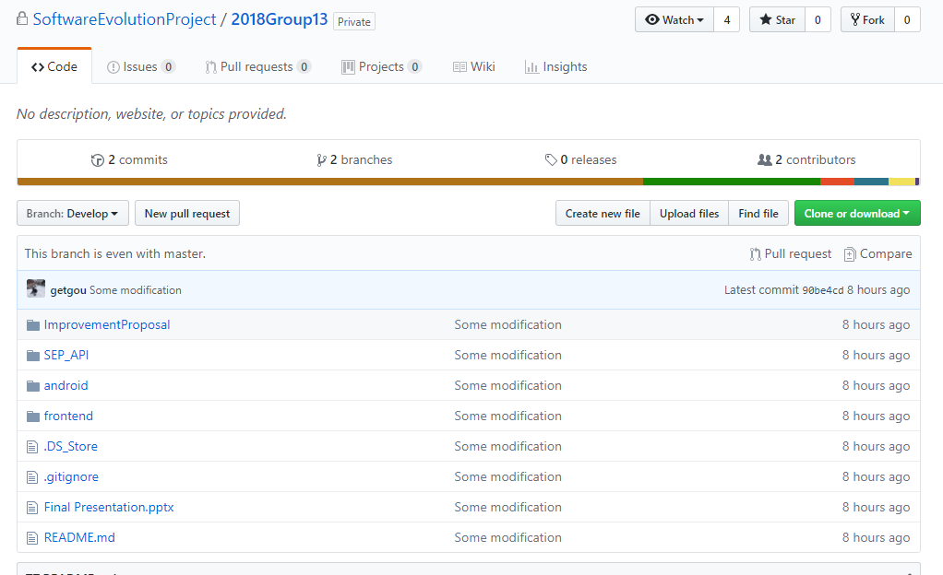

**Web-Frontend**Make sure to install Angular (https://docs.angularjs.org/tutorial ,  
https://docs.angularjs.org/misc/started) *  
• npm install -g @angular/cli  
In the frontend folder:  
• ng serve  
• Open in browser: localhost:4200  
*https://www.npmjs.com/

**Web-Frontend  
LINUX INSTALLATION GUIDE**

**Web-Frontend  
OSX INSTALLATION GUIDE**

**Web-Frontend – Typical Errors**

**Web-Frontend – Typical Errors**  
Should the log-in screen be blank. Check inspect Elements & Console. For some versions of  
Angular the variable “global” in crossvent/node_modules/costum-event/index.js is not  
defined. The known workaround (https://github.com/swimlane/ngx-dnd/issues/81) is to  
add the following to the header of frontend/src/index.html:  
<!-- https://github.com/aws/aws-amplify/issues/678 fix: -->  
<script>  
if (global === undefined) {  
var global = window;  
}  
</script>  
<!-- https://github.com/aws/aws-amplify/issues/678 fix end-->

**Connecting the Source Code to the Backend**

From frontend\src\app\model\API.ts:

* Change BASE_URL (line 6) to “[http://localhost:{your port number}/](http://localhost:%7byour%20port%20number%7d/)”;
* Change read only TOKEN (line 7) to “[http://localhost:{your port number}/](http://localhost:%7byour%20port%20number%7d/)token”;

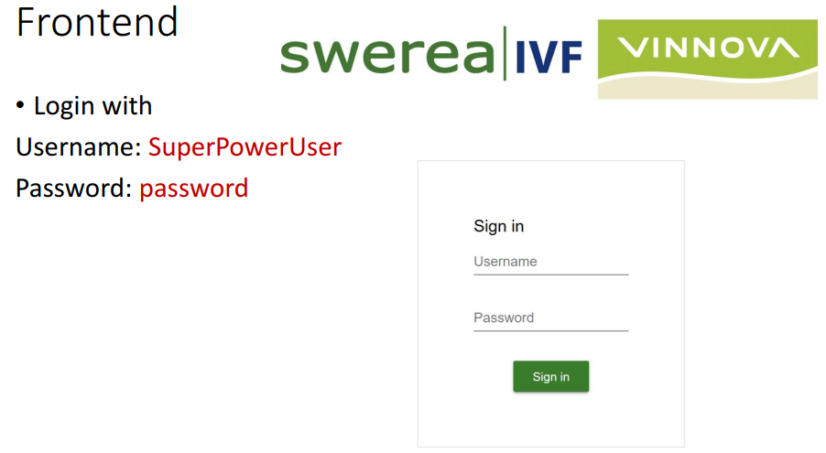

**Compiling and Running the Android-frontend**

**Location: “android”**

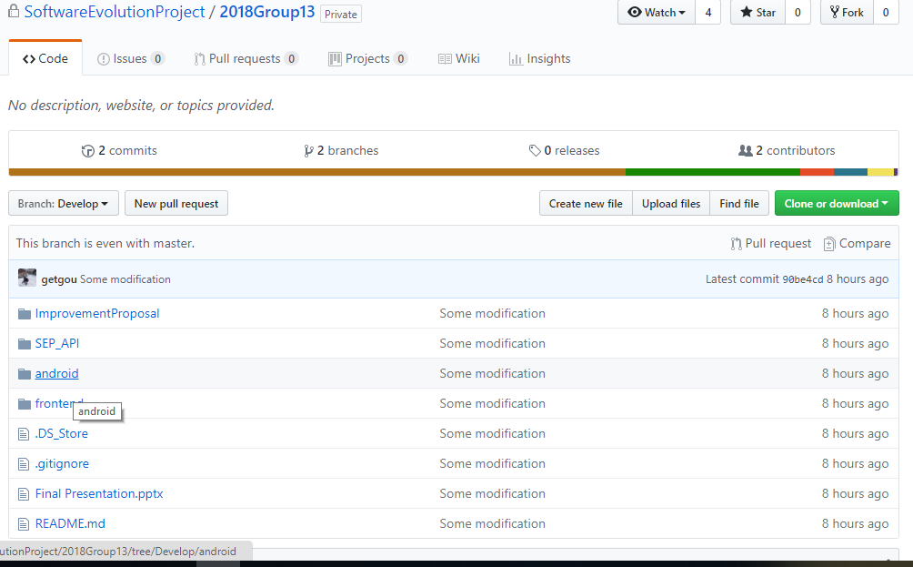

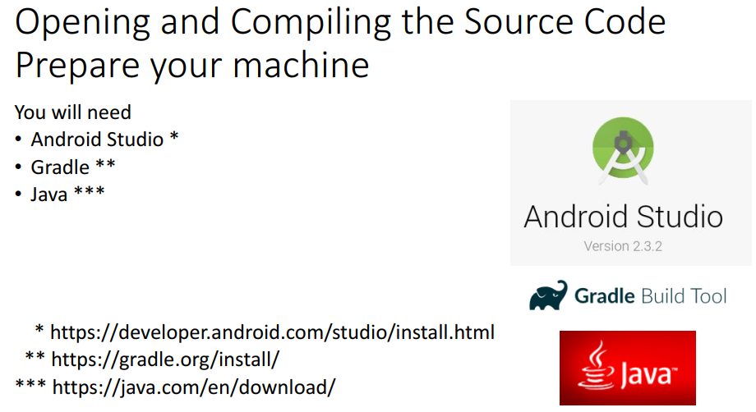

Opening the Source Code with Android Studio

**opening the Source Code with Android Studio**

Load the project for  
the first time  
• The project already  
includes gradle files,  
so chose “Import  
project”

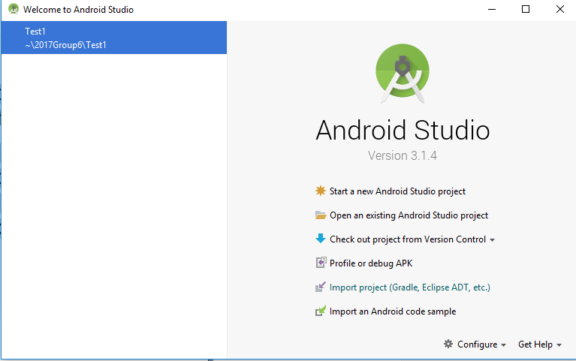

**Compiling the source code with Android Studio**

Missing dependencies  
• Try to build the apk  
• Note: the initial build *will  
fail* for several reasons,  
such as missing  
dependencies and  
version issues  
• Please, see the following  
slides on how to resolve  
the issues

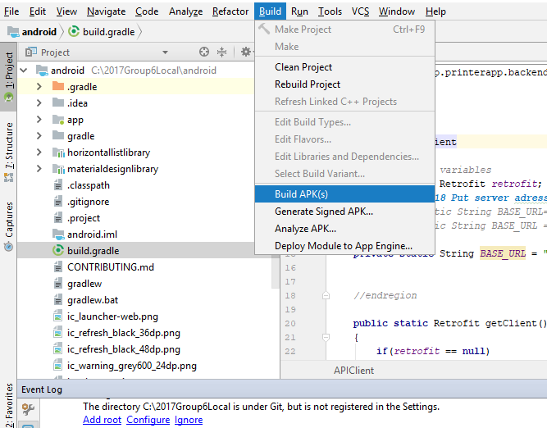

**Compiling the Source Code with Android Studio**

**Typical Errors**

Connecting the Source Code to the Backend

Android Frontend

Login with  
Username: SuperPowerUser  
Password: password

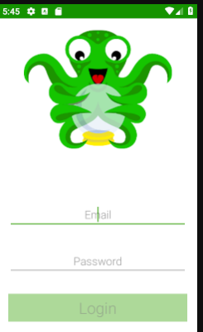

**Compiling and Running the Backend**

**Location: “SEP_API/Swerea API”**

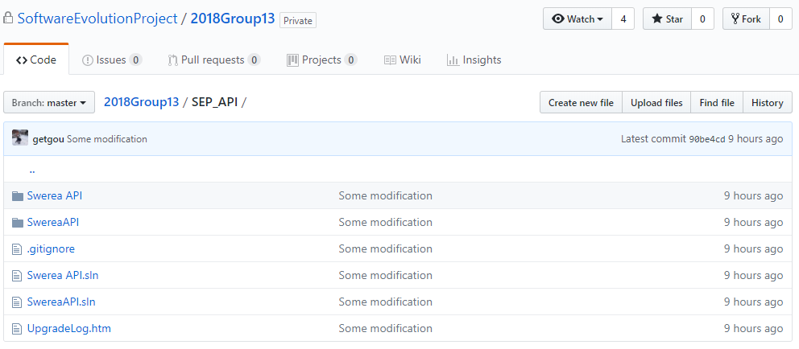

So far you are able to compile the web front end and the android, now it is time to compile the back end and generate all the required database tables.

**IDE**Install Visual Studio 2017 for Web Development  
Make sure to install the following Workloads:  
- ASP.NET and web development  
- Data storage and processing

**Download Visual Studio Installer**

* From Dreamspark:
* For GU students: <https://licenser.gu.se/gu/imagine>
* For Chalmers students: <https://student.portal.chalmers.se/sv/kontaktochservice/it-passerkortkopiering/programvaror/Sidor/programvaror.aspx>
* Expected outcome: An installer file

**Install Visual Studio 2017**

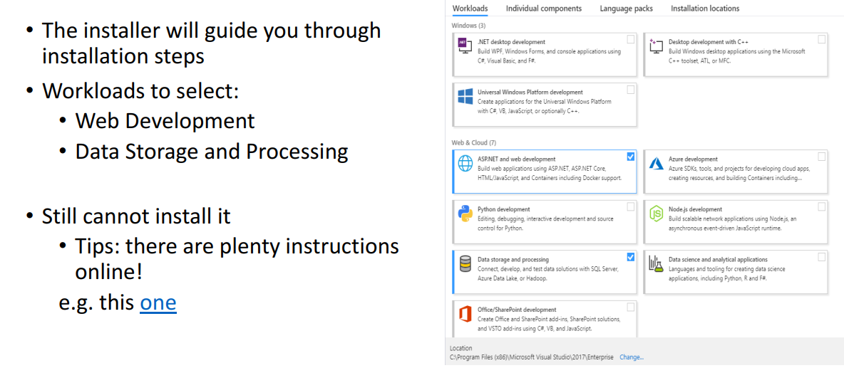

**Install Visual Studio 2017 – Expected outcome**

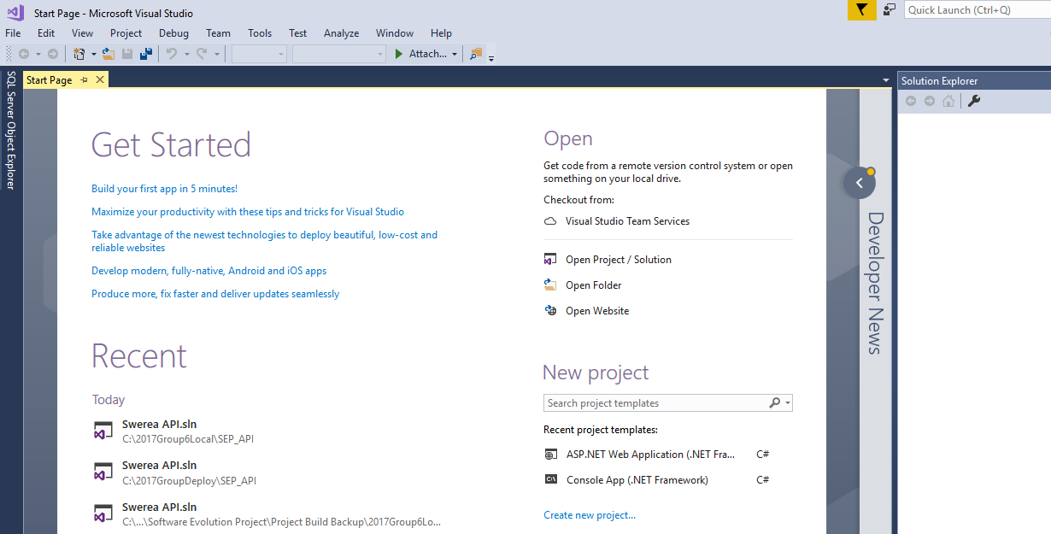

**Open Swerea API project**

Open file …\2018Group18-develop\Swerea API.sln (using VS2017)  
• Known issues: References are missing

Some example error figures should go here:

**Resolve missed references**

* Using Nuget Package Management
* In visual studio : Go to Tools =>NuGet Package Manager=>package Manager Console
* Install all required missed reference from Nuget Gallery: <https://www.nuget.org/packages>
* on the search bar of NuGet Gallery write the package you want to install=>Hit search=>Copy the installation Command=>paste it in visual studio Nuget Package manager Console=>hit enter to install the package.

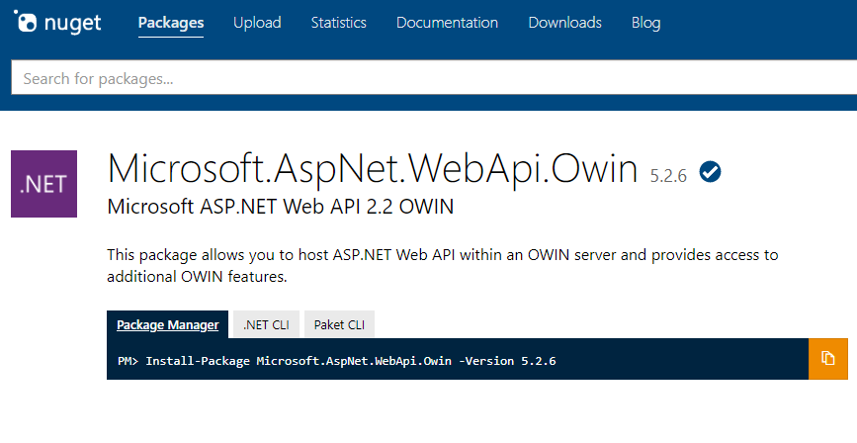

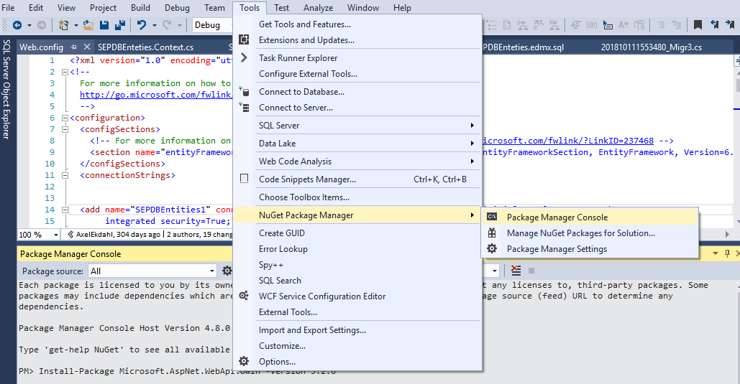

**Resolve missed references - useful commands**

* Reinstall existing (and maybe expired) package:
* Update-Package [package_name_without_brackets] -Reinstall
* Install new package:
* Install-Package [package_name_without_brackets] -Version [version_without_brackets]

**Example of Resolving missed references – known issues/solutions**

**Connecting the Back End to Local Microsoft SQL Server 2017**

**Install Microsoft SQL Server 2017**

* Run the installer as administrator=>Select an installation type=>follow the installation instruction

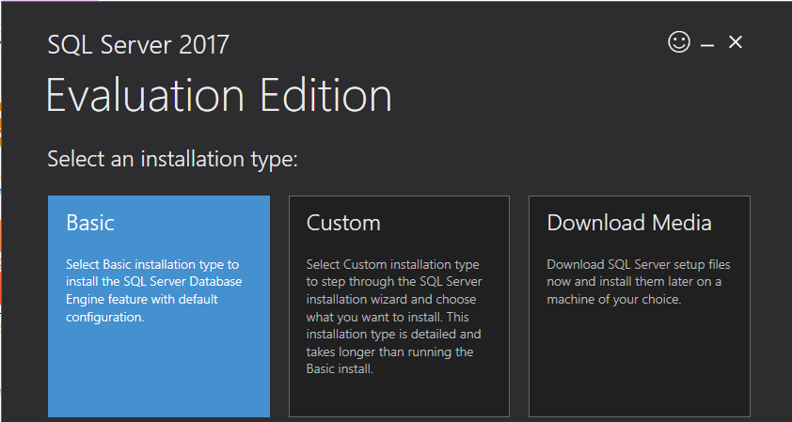

**Install Microsoft SQL Server 2017 – Expected outcome**

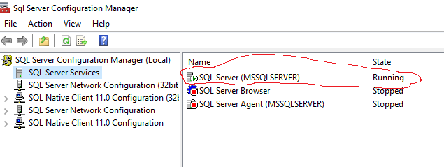

**Open the backend**

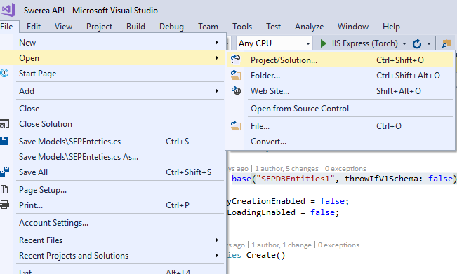

* Modify the database connection string
* Open web.config =>Remove/Comment all previous connection strings
* Generate database from model
* Go to Models-> Expand SEPDBEntities.edmx -> Expand SEPDBEntities.Context.tt ->  
  SEPDBEntities.Context.cs.
* Make sure the class and constructor has the same name
* Go to Models=>SEPEnteties=> Make sure the constructor of SEPEnteties is drived from : base("your connection string name", throwIfV1Schema: false)
* In visual studio go to Tools -> Nuget Package Manager -> Package  
  Manager Console Run the following commands

1. “Enable-Migrations -ContextTypeName Swerea_API.Models.SEPDBEntities”

N.B: If migration is already enable previously just jump to the next step

1. Run the command: “add-migration”

N.B: if you get an error stating like the following: “At least one of the input paths is not valid because either it is too long, or it has incorrect format”.

Reformat your connection string: =>delete all lines before data source, App=EntityFramework&quot and Replace providerName="System.Data.EntityClient" by

providerName="System.Data.SqlClient"

Example:

<add name="SEPDBEntities1" connectionString="~~metadata=res://*/Models.SEPDBEnteties.csdl|res:~~

~~//*/Models.SEPDBEnteties.ssdl|res://*/Models.SEPDBEnteties.msl;~~

~~provider=System.Data.SqlClient;provider connection string=&quot;~~

data source=(localdb)\ProjectsV13;initial catalog=MySwereaDb1;

integrated security=True;MultipleActiveResultSets=True;

~~App=EntityFramework&quot~~;" providerName="System.Data.EntityClient" />

After final modification the above connection string becomes:

<add name="SEPDBEntities1" connectionString= "data source=(localdb)\ProjectsV13;initial catalog=MySwereaDb1;

integrated security=True; MultipleActiveResultSets=True;" providerName="System.Data.SqlClient" />

N.B: if you get an error message of pending migration like the following:

“Unable to generate an explicit migration because the following explicit migrations are pending: [201810111005175_Migrat1]. Apply the pending explicit migrations before attempting to generate a new explicit migration.”

Then Expand Migration =>delete all pending migrations and re-run “add-migration”

1. Run the command: “update-database”

Go to Microsoft SQL Server Management Studio then refresh the database

Expand the tables under your database

Your database should now have six tables generated from the first initial migration.

Note: These tables are only regarding .NET Identity. Hence to generate all the tables required run the SQL scripts under SEPDBEnteties.edmx.sql

Finally, you will have all the tables generated.

Run the project

Done

**Use Postman to ping the backend**

Open post man:

* Run the following command from post man to ping the backend:
* Method: post
* URL: “[http://localhost:{your port number}/](http://localhost:%7byour%20port%20number%7d/)token”;
* On the body: write the following:

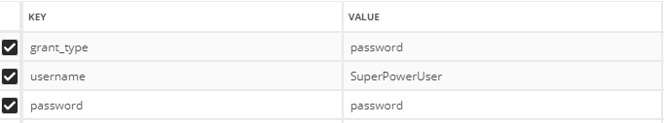

* Select “x-www-form-urlencoded” then press send

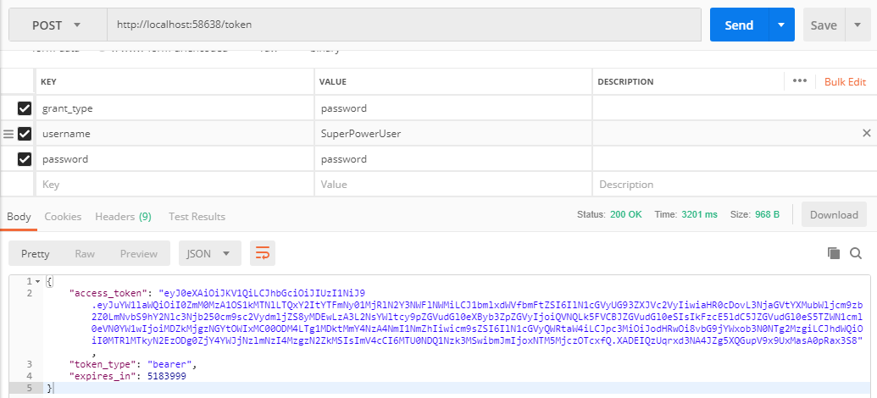

* by this time, you should get an access token.